

**Bangladesh University of Business and Technology (BUBT)**

Course No. : **CSE - 465**

Course Title: **Machine Learning**

Semester: **Summer 2022 [Tri-Semester]**

Survey Paper Name: **Electrocardiogram Heartbeat Classification Using Convolutional Neural Networks for the Detection of Cardiac Arrhythmia**

**Submitted by -**

Name: Minhazur Rahman Hemel

ID: 17182103134

Name: Ruksana

ID: 17182103120

Name:Mostakin Ahamed

ID: 17182103123  
Name: Jannatul Kobra

ID: 17182103296

Name: Tahmina Akther

ID: 18192103225

**Submitted to -**

**Khan Md. Hasib**

**Faculty Member, Department of CSE, BUBT**

**Summary of the Paper:** This work is based on the classification of five classes of ECG arrhythmic signals from Physionet's MIT-BIH Arrhythmia Dataset. Their proposed model is a Convolutional Neural Network (CNN) customized for the categorization of the ECG signals. And for this their result testifies that the planned CNN model can successfully categorize arrhythmia with an overall accuracy of 95.2%. The average precision and recall of the proposed model are 95.2% and 95.4% respectively.

**Unique Contribution of the Paper:** They claimed that this model can effectively be used to detect irregularities of heart rhythm at an early stage. These techniques faced a lot of significant challenges due to the morphological features of the signal having the nature of being highly individual and variable i.e. same symptoms of arrhythmia may display different morphologies of the signal in varying circumstances. Hence, a good classification performance could not be achieved when exposed to new ECG data.

**How the proposed model works in the paper:**

For the automatic categorization of ECG heartbeat, MITBIH Arrhythmia dataset is utilized to assess the performance of the model using 1-D CNN.

Working steps is given below -

A. Data Acquisition

B. ECG Signal Preprocessing

C. Data Augmentation and Splitting

D. Proposed 1-D CNN ECG Heartbeat Classifier

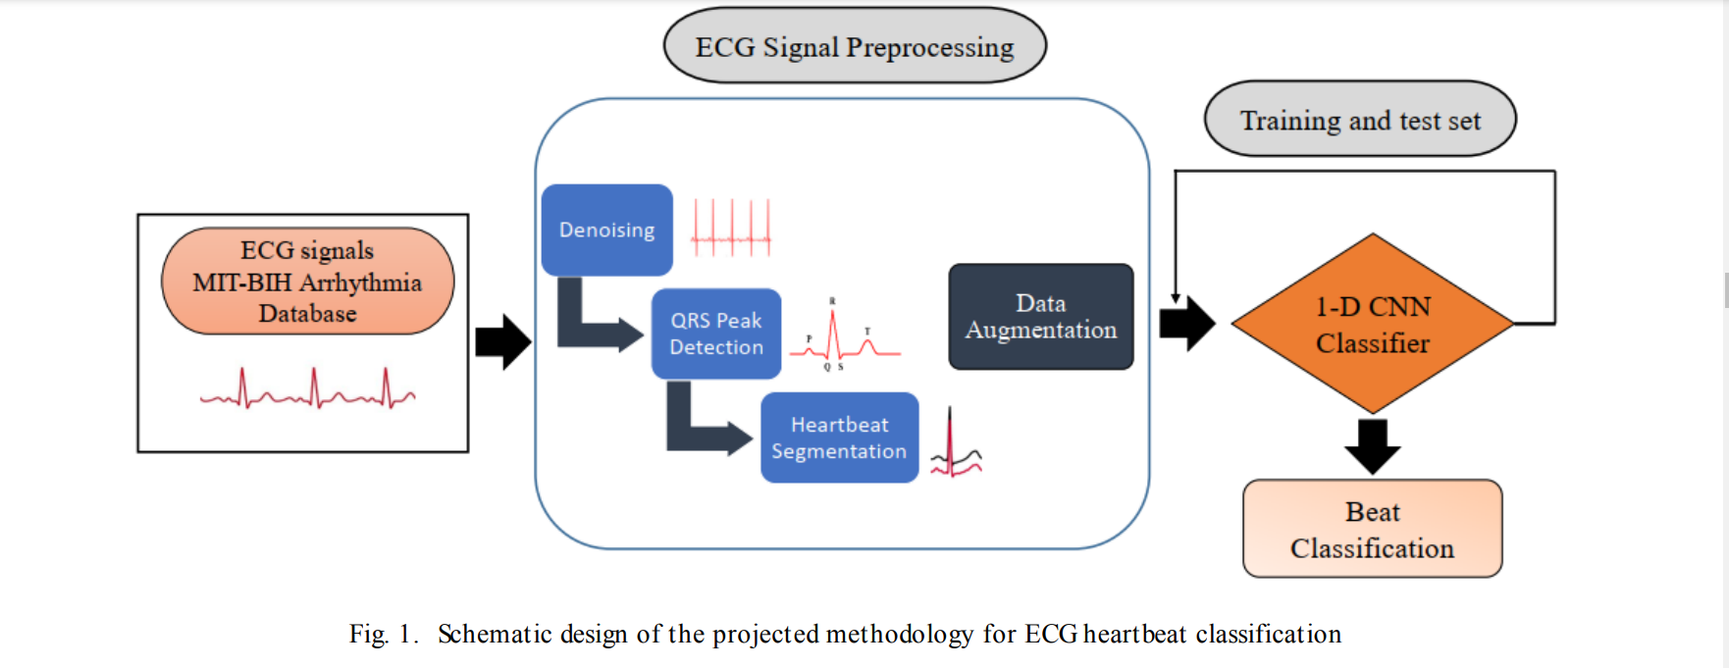

**Advantages of the paper:**

These techniques became

- time-consuming,

- expensive,

- susceptible to the loss of data in the feature extraction phase

- a good classification performance could not be achieved when exposed to new ECG data

- The suggested ECG arrhythmia classifier can be applied in several biomedical applications such as sleep staging, a medical robot that monitors the ECG signal and assists the medical experts to detect cardiac arrhythmia more accurately.

**Disadvantages of the paper:**

Additionally, these techniques faced a lot of significant challenges due to the morphological features of the signal having the nature of being highly individual and variable i.e. same symptoms of arrhythmia may display different morphologies of the signal in varying circumstances.

**Conclusion:** In this study, a deep learning 1-D CNN is proposed for the automatic ECG heartbeat categorization to categorize five different types of cardiac arrhythmia. For better performance, the ECG signals were processed using several preprocessing steps (denoising, peak detection, heartbeat segmentation). The proposed ECG heartbeat classification systems performance was validated from Physionet's MIT-BIH Arrhythmia Dataset.